PAI Assignment 1
1)
from itertools import combinations

transactionLog = [
{'orderId': '1001', 'customerId': 'cust_Ahmed', 'productId': 'prod_10'},
{'orderId': '1001', 'customerId': 'cust_Ahmed', 'productId': 'prod_12'},
{'orderId': '1002', 'customerId': 'cust_Bisma', 'productId': 'prod_10'},
{'orderId': '1002', 'customerId': 'cust_Bisma', 'productId': 'prod_15'},
{'orderId': '1003', 'customerId': 'cust_Ahmed', 'productId': 'prod_15'},
{'orderId': '1004', 'customerId': 'cust_Faisal', 'productId': 'prod_12'},
{'orderId': '1004', 'customerId': 'cust_Faisal', 'productId': 'prod_10'},
]

productCatalog = {
'prod_10': 'Wireless Mouse',
'prod_12': 'Keyboard',
'prod_15': 'USB-C Hub',
}

# 1. Transform Data
def processtransactions(transactionLog):
uniqueproducts={}
for i in transactionLog:
customerID=i["customerId"]
productId=i["productId"]
if customerID not in uniqueproducts:
uniqueproducts[customerID]= {productId}
else:
uniqueproducts[customerID].add(productId)
return uniqueproducts

print(processtransactions(transactionLog))

# 2. Find Pairs
def findFrequentPairs(transactionLog):
orders = {}
for transaction in transactionLog:
order = transaction['orderId']
product = transaction['productId']

if order not in orders:
orders[order] = {product}
else:
orders[order].add(product)

pair_counts = {}

for product_set in orders.values():

if len(product_set) < 2:
continue

sorted_products = sorted(list(product_set))

pairs = combinations(sorted_products, 2)

for pair in pairs:
pair_counts[pair] = pair_counts.get(pair, 0) + 1

return pair_counts

frequent_pairs = findFrequentPairs(transactionLog)
print("--- Frequent Pairs (by Order) ---")
print(frequent_pairs)

# 3. Recommendation
def getRecommendations(targetProductId, frequentPairs):
recommendations = []

for pair, count in frequentPairs.items():
if targetProductId in pair:
other_product = ''
if pair[0] == targetProductId:
other_product = pair[1]
else:
other_product = pair[0]

recommendations.append( (other_product, count) )

recommendations.sort(key=lambda x: x[1], reverse=True)

return recommendations

# 4. Report Generation
def generateReport(targetProductId, recommendations, catalog):
print("-------------------------------------------------")

# --- THIS IS THE FIXED LINE ---
# Use .get() to avoid a KeyError if the product ID is not in the catalog
product_name = catalog.get(targetProductId, "Unknown Product")
print(f"Product Recommendation Report for: {product_name}")

print("-------------------------------------------------")

if not recommendations:
print("No recommendations found.")
return

ranks = [rank for rank, _ in enumerate(recommendations, start=1)]
prod_ids = [prod_id for prod_id, count in recommendations]
counts = [count for prod_id, count in recommendations]
prod_names = [catalog[pid] for pid in prod_ids]

for rank, name, count in zip(ranks, prod_names, counts):
print(f" {rank}. {name} (Purchased together {count} times)")

frequent_pairs = findFrequentPairs(transactionLog)
target_product = 'prod_10'
recommendations = getRecommendations(target_product, frequent_pairs)
generateReport(target_product, recommendations, productCatalog)

# This part will no longer crash
target_product_2 = 'prod_11'
recommendations_2 = getRecommendations(target_product_2, frequent_pairs)
generateReport(target_product_2, recommendations_2, productCatalog)
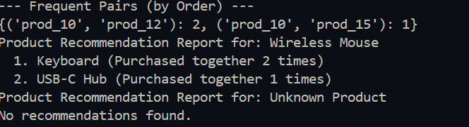

2)
allPosts = [
{'id': 1, 'text': 'I LOVE the new #GulPhone! Battery life is amazing.'},
{'id': 2, 'text': 'My #GulPhone is a total disaster. The screen is already broken!'},
{'id': 3, 'text': 'Worst customer service ever from @GulPhoneSupport. Avoid this.'},
{'id': 4, 'text': 'The @GulPhoneSupport team was helpful and resolved my issue. Great service!'},
]

PUNCTUATION_CHARS = '!"#$&\'()*+,-./:;<=>?@[\\]^_`{|}~'
STOPWORDS_SET = {
'i', 'me', 'my', 'a', 'an', 'the', 'is', 'am', 'was', 'and',
'but', 'if', 'or', 'to', 'of', 'at', 'by', 'for', 'with', 'this', 'that'
}
POSITIVE_WORDS_SET = {'love', 'amazing', 'great', 'helpful', 'resolved'}
NEGATIVE_WORDS_SET = {'disaster', 'broken', 'worst', 'avoid', 'bad'}

def preProcessText(text, punctuations, stopWords):
normalizedText = text.lower()
without_punctuation = "".join(char for char in normalizedText if char not in punctuations)
preCleanedWords = without_punctuation.split()
CleanedWords = [word for word in preCleanedWords if word not in stopWords]
return CleanedWords

def analyzePosts(postsList, punctuation, stopwords, positive, negative):
analyzed_posts = []
cleaned_texts = map(lambda post: preProcessText(post['text'],punctuation,stopwords),postsList)
for post, cleaned_words in zip(postsList, cleaned_texts):
score = 0
for word in cleaned_words:
if word in positive:
score += 1
elif word in negative:
score -= 1
analyzed_posts.append({
'id': post['id'],
'text': post['text'],
'processedText': cleaned_words,
'score': score
})
return analyzed_posts

def getFlaggedPosts(scoredPosts, sentimentThreshold=-1):
return [post for post in scoredPosts if post['score'] <= sentimentThreshold]

def findNegativeTopics(flaggedPosts):
topic_counts = {}
for post in flaggedPosts:
words = post['text'].split()
for word in words:
if word.startswith('#') or word.startswith('@'):
cleanedTopic = "".join(char for char in word if char not in PUNCTUATION_CHARS).lower()
topic_counts[cleanedTopic] = topic_counts.get(cleanedTopic, 0) + 1
return topic_counts

scored_posts = analyzePosts(allPosts,PUNCTUATION_CHARS,STOPWORDS_SET,POSITIVE_WORDS_SET,NEGATIVE_WORDS_SET)

print("*Scored Posts*\n")
print(scored_posts)
print("\n")

flaggedposts = getFlaggedPosts(scored_posts, sentimentThreshold=-1)
print("*Flagged Posts*\n")
print(flaggedposts)
print("\n")

negativetopics = findNegativeTopics(flaggedposts)
print("*Negative Topics*\n")
print(negativetopics)

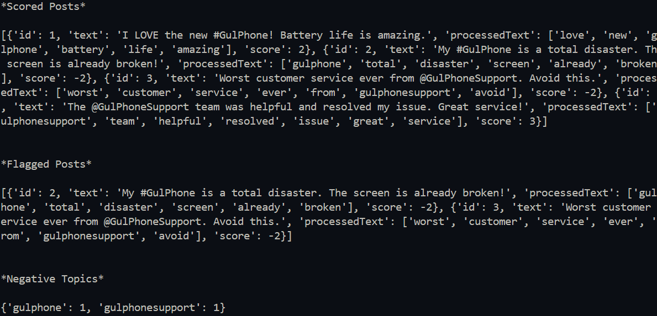
3)
import time

class package:
def __init__(self, packageid, weightinkg):
self.packageid = packageid
self.weightinkg = weightinkg

class drone:
statuses = {'idle', 'delivering', 'charging'}

def __init__(self, droneid, maxload):
self.droneid = droneid
self.maxload = maxload
self.__status = 'idle'
self.__timer = 0
self.__currentpackage = None

def getstatus(self):
return self.__status

def setstatus(self, newstatus):
if newstatus in drone.statuses:
self.__status = newstatus

if newstatus == 'delivering':
self.__timer = 5
print(f"drone {self.droneid} has to deliver package: {self.__currentpackage.packageid}")
elif newstatus == 'charging':
self.__timer = 3
self.__currentpackage = None
print(f"drone {self.droneid}: charging")
elif newstatus == 'idle':
self.__timer = 0
self.__currentpackage = None
else:
print(f"error: invalid status '{newstatus}' with drone id: {self.droneid}")

def assignpackage(self, packageobj):
if self.getstatus() != 'idle':
return False

if packageobj.weightinkg > self.maxload:
print(f"drone {self.droneid}: package {packageobj.packageid} ({packageobj.weightinkg}kg) is too heavy (max {self.maxload}kg).")
return False

self.__currentpackage = packageobj
self.setstatus('delivering')
return True

def updatetick(self):
if self.__timer > 0:
self.__timer -= 1

if self.__timer == 0:
if self.getstatus() == 'delivering':
print(f"Drone: {self.droneid} has completed the delivery.")
self.setstatus('charging')
elif self.getstatus() == 'charging':
print(f"Drone: {self.droneid} charging completed, now its idle.")
self.setstatus('idle')

class fleetmanager:
def __init__(self):
self.drones = {}
self.pendingpackages = []

def adddrone(self, droneid, maxloadinkg):
new_drone = drone(droneid, maxloadinkg)
self.drones[droneid] = new_drone
print(f"Drone: {droneid} with maximum load {maxloadinkg}kg is added.")

def addpackagetoqueue(self, package):
self.pendingpackages.append(package)
print(f"Package: {package.packageid} weighing {package.weightinkg}kg is added. ")

def dispatchjobs(self):
print("\n*dispatching jobs")
toberemovedpackages = []
for package in self.pendingpackages:
for droneid, drone in self.drones.items():
if drone.assignpackage(package):
toberemovedpackages.append(package)
break
for package in toberemovedpackages:
self.pendingpackages.remove(package)

def simulationtick(self):
print(f"\n*simulation tick")
for droneid, drone in self.drones.items():
drone.updatetick()

if __name__ == "__main__":

print("*initializing fleet")
manager = fleetmanager()
manager.adddrone("d1", 1)
p1 = package("p1", 1)

manager.addpackagetoqueue(p1)
for tick in range(1, 15):
print(f"\ntick: {tick}")
manager.dispatchjobs()
manager.simulationtick()
if tick == 2:
manager.addpackagetoqueue(package("p2", 2))
time.sleep(1)

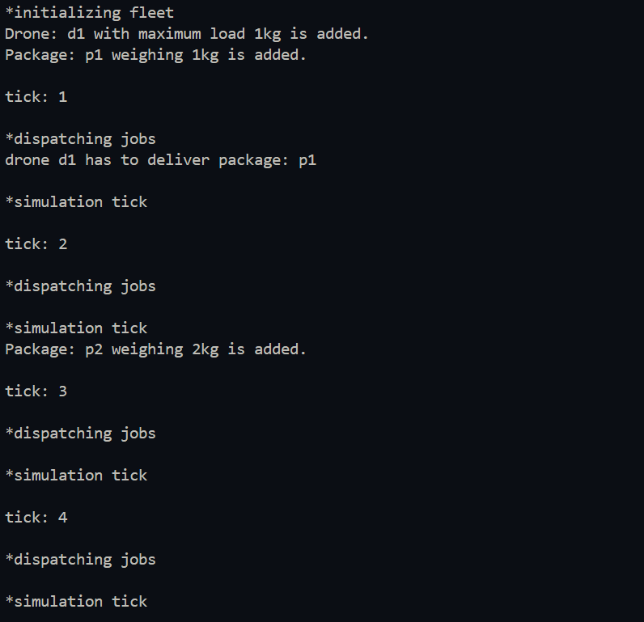
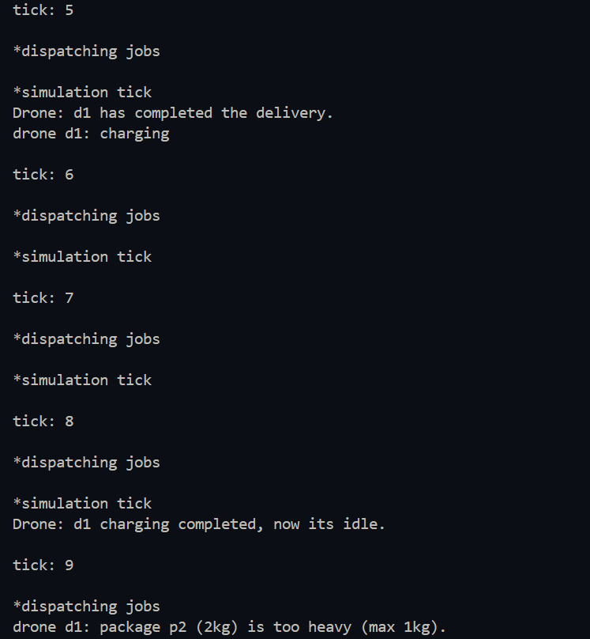
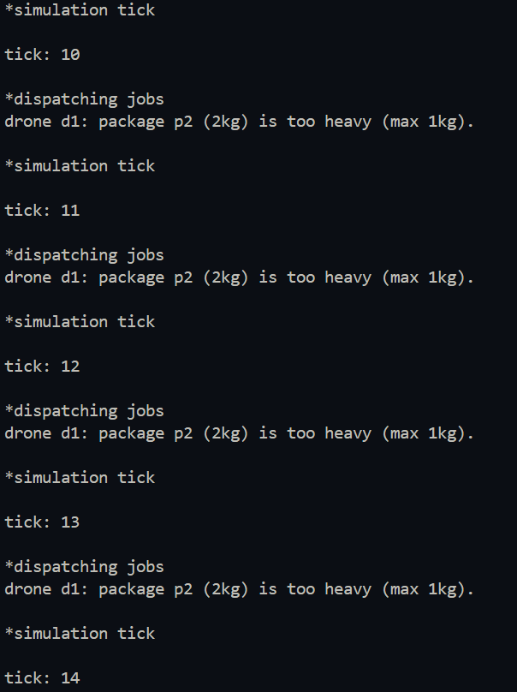
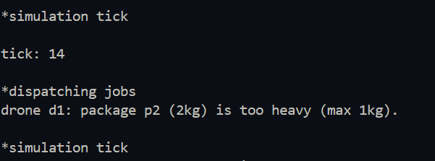
4)
class Image:
def __init__(self, initial_pixels):
self.pixel = initial_pixels

def __repr__(self):
return f"<Image pixels={self.pixel}>"

def transformation(self, transformationfoo):
newpixels = transformationfoo(self.pixel)
self.pixel = newpixels
print(f"After: {self}")

def getCopy(self):
return [[pixel for pixel in row] for row in self.pixel]

def horizontalflip(pixel):
return [row[::-1] for row in pixel]

def brightness(pixel, brightness):
return [[pixel + brightness for pixel in row] for row in pixel]

def rotate90(pixel):
return [list(reversed(row)) for row in zip(*pixel)]

class AugmentationPipeline:
def __init__(self):
self.steps = []

def addstep(self, transformfoo):
self.steps.append(transformfoo)
print(f"Added step: {transformfoo.__name__}")

def imageprocessing(self, originalImage):
print("\nPipeline in Process...")
augmentedImagesList = []
for func in self.steps:
pixel_data_copy = originalImage.getCopy()
augmented_data = func(pixel_data_copy)
new_image = Image(augmented_data)
augmentedImagesList.append(new_image)
return augmentedImagesList

if __name__ == "__main__":

orgpixels = [
[10, 20, 30], [40, 50, 60]
]

img = Image(orgpixels)
print(f"Image Before: {img}")

pip = AugmentationPipeline()

pip.addstep(horizontalflip)

pip.addstep(
lambda data: brightness(data, 50)
)

pip.addstep(rotate90)

augmented_list = pip.imageprocessing(img)

print("\nPipeline is completed.")
for aug_img in augmented_list:
print(aug_img)

print(f"\noriginal image is remained unchanged: {img}")

